National University of Computer and Emerging Sciences



Laboratory Manual of Operating Systems

for

Introduction to Information and Communication Technology

(CL -1000)
Fall 2025

Department of Computer Science
FAST-NU, Lahore, Pakistan

- nano - Create a file
The nano command in Ubuntu is a simple and easy-to-use text editor that runs in the terminal. It provides basic text editing functionalities and is particularly popular among beginners due to its simplicity and straightforward interface.
nano provides a list of keyboard shortcuts or keybindings at the bottom of the terminal window to help you navigate and perform various editing tasks. Some common keybindings include:
- Ctrl + O: Save the file.
- Ctrl + X: Exit nano.
- Ctrl + G: Display help.
- Ctrl + K: Cut (delete) the current line or marked text.
- Ctrl + U: Paste the cut text.
- Ctrl + W: Search for text within the file
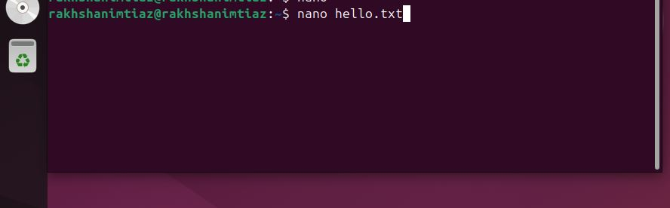

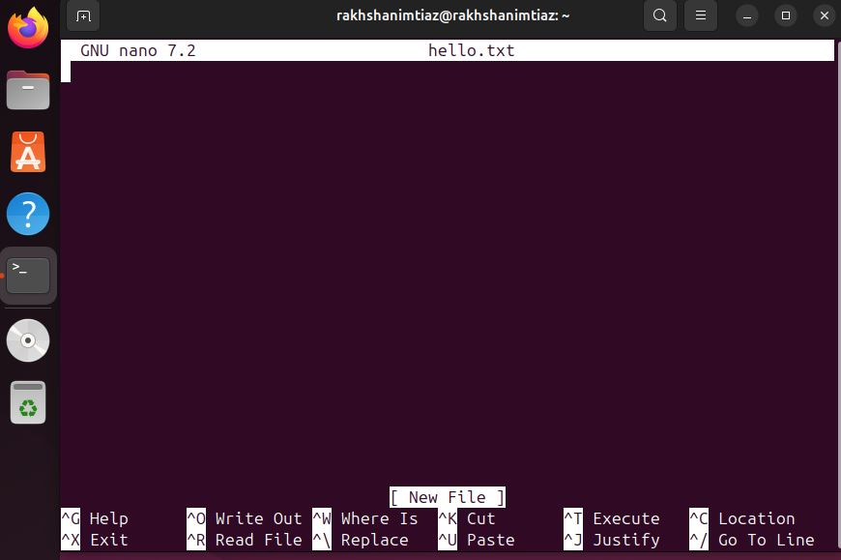
- touch - Create an empty file
  - Purpose: touch command is used to create new empty files. It is often used to create placeholder files or update the timestamp of existing files.
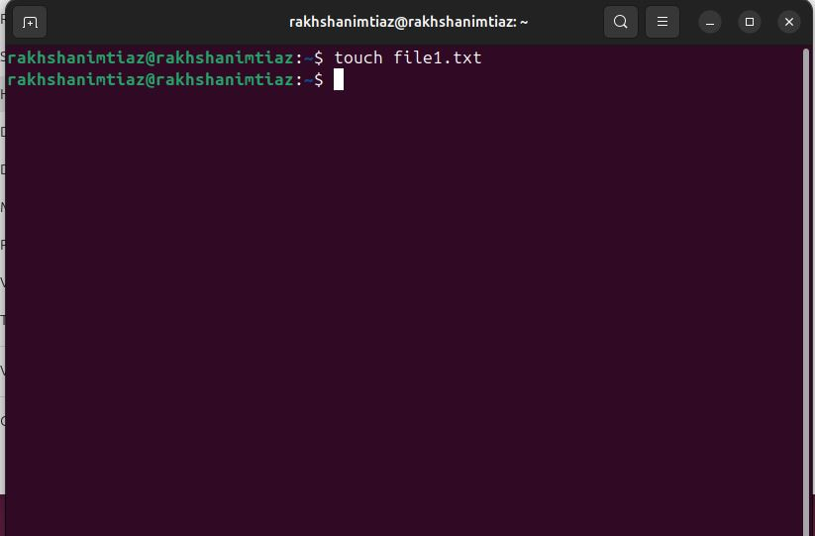

- Gedit - gedit in Linux is a GUI-based text editor. It is mainly used for creating and editing text files

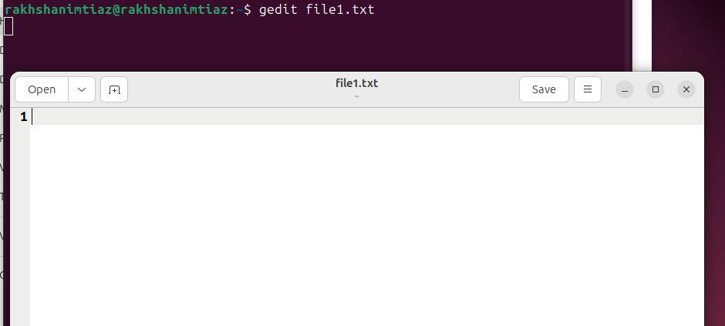

- cat - display file content
  - Purpose: cat command is used to display the contents of one or more files. It is often used to view the content of text files on the terminal.

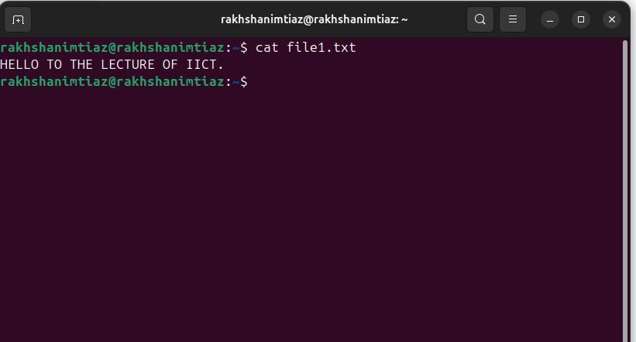

- cp - Copy
  - Purpose: cp command is used to copy files and directories from one location to another. It helps in duplicating files or directories for backup or sharing purposes.
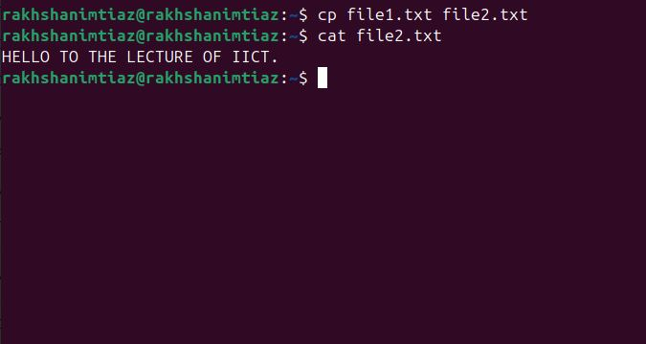
- rm - Remove
  - Purpose: rm command is used to remove files and directories from the file system

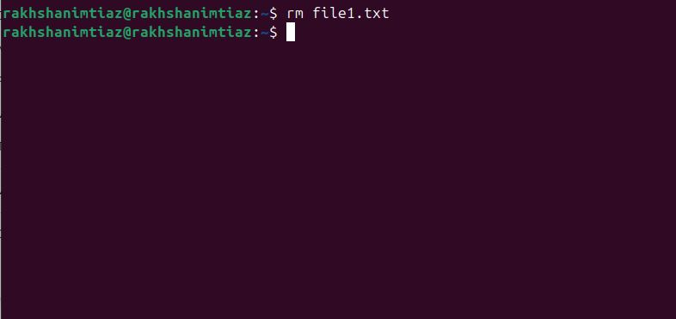

- grep - searching plain-text data sets for lines that match a regular expression
• Scan files line by line.
• Identify lines that contain a specified pattern (which can be a simple string or a complex regular expression).
• Print the matching lines to standard output (or perform other actions based on options).
Syntax: grep [options] pattern [file...]
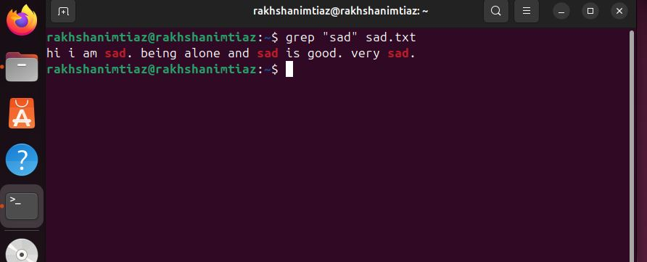

- mv – Rename a file
  - Purpose: mv command is used to rename files
  - Syntax: mv oldname.txt newname.txt
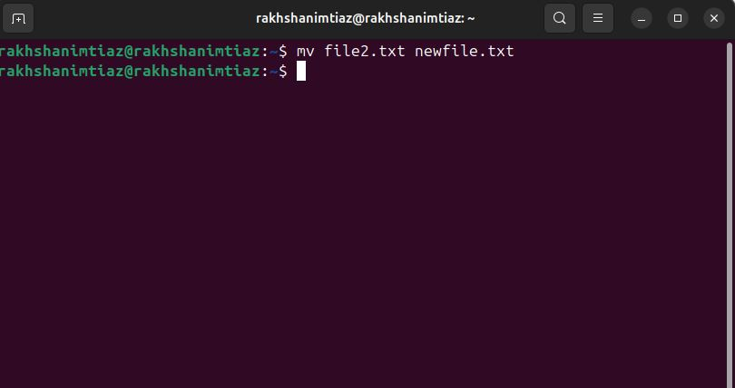

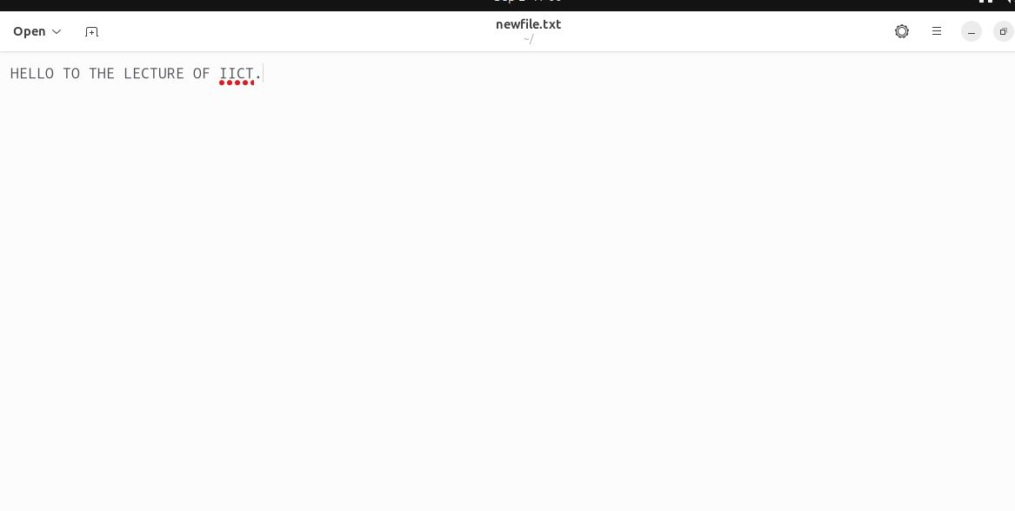

- find – find or search a file
Syntax: find . -name “filename.txt”
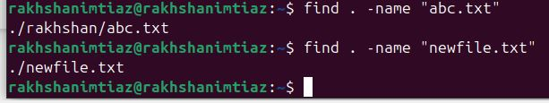

Task to be Submitted

- Create a new empty file “practice.txt” by using touch command.

- Add the following content into “practice.txt”:

Linux is a powerful operating system. Linux supports multitasking. File management in Linux is simple. grep is used to search inside files. We are practicing Linux commands.

- Display the content of the file “practice.txt”.
- Search for the word Linux inside “practice.txt”.
- Copy the content of “practice.txt “file to a “backup file.txt”
- Delete the “practice.txt” file.

